**Ryan Hatch**

**DAD 220 Module 5-3 Major Activity**

1. **Sales by region:**
   1. **Analyze sales data by state to determine where the company has the largest customer base.**  
      > SELECT State, count(*) FROM Customers GROUP BY State order by count(*) DESC;  
        
      Massachusetts has 982 customers, which is 128 more than Arkansas and is 15% greater in counts. In comparison through states, none the less, you can see Massachusetts carries 2.58% of the business which is 0.33% greater than Arkansas.  
        
      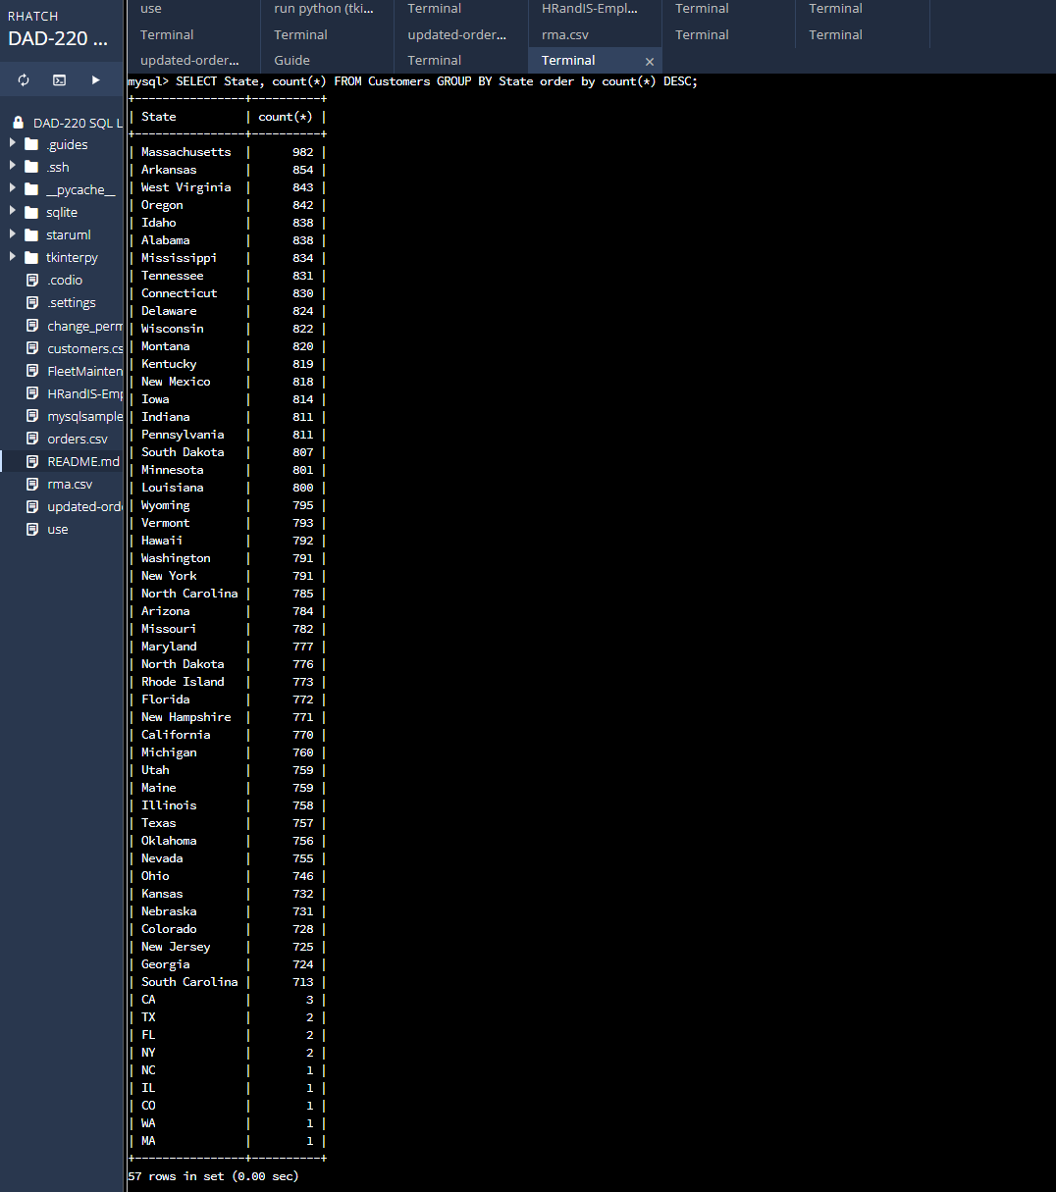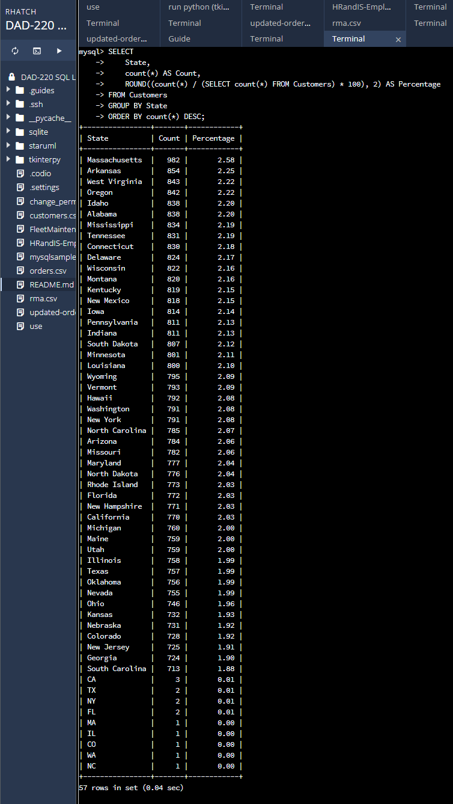
   2. **Analyze the data to determine the top three products sold in the United States.**  
      > SELECT Orders.SKU, count(*) FROM Orders GROUP BY Orders.SKU ORDER BY count(*) DESC;  
      The top three products sold in the United States are the BAS-48-1 C, ENT-48-40F, and the ENT-48-10F.  
        
      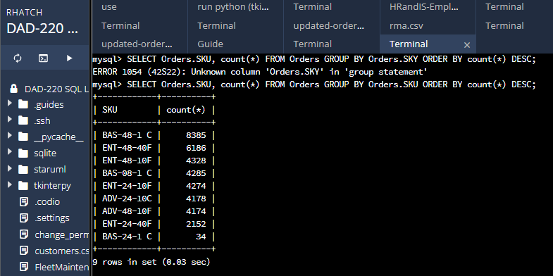
   3. **Analyze the data to determine the top three products sold in the southeastern region of the United States.**
2. **Southeastern states to include in your analysis: Virginia, North Carolina, South Carolina, and Georgia**  
     
   > SELECT Orders.SKU, count(*) FROM Orders  
   > INNER JOIN Customers ON Orders.CustomerID = Customers.CustomerID  
   > WHERE Customers.State IN (‘North Carolina’,’South Carolina’,’Georgia’,’Virginia’)  
   > GROUP BY Orders.SKU  
   > ORDER BY count(*) DESC;  
     
   BAS-48-1 C, ENT-48-40F, BAS-08-1 C  
     
   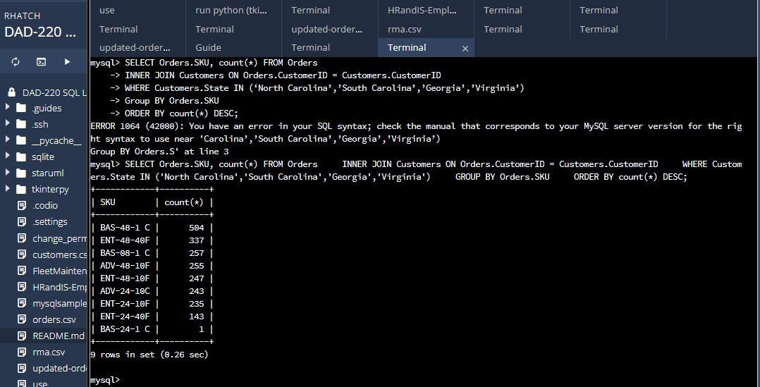  
   1. **Returns by region:**
      1. **Analyze the data to determine the top three products returned in the United States.**  
         SELECT Orders.SKU, count(*) FROM Customers INNER JOIN Orders ON Customers.CustomerID = Orders.CustomerID INNER JOIN RMA ON RMA.OrderID = Orders.OrderID

> GROUP BY Orders.SKU  
> ORDER BY count(*) DESC;  
BAS-48-1 C, ENT-48-40F, and ENT-48-10F  
  
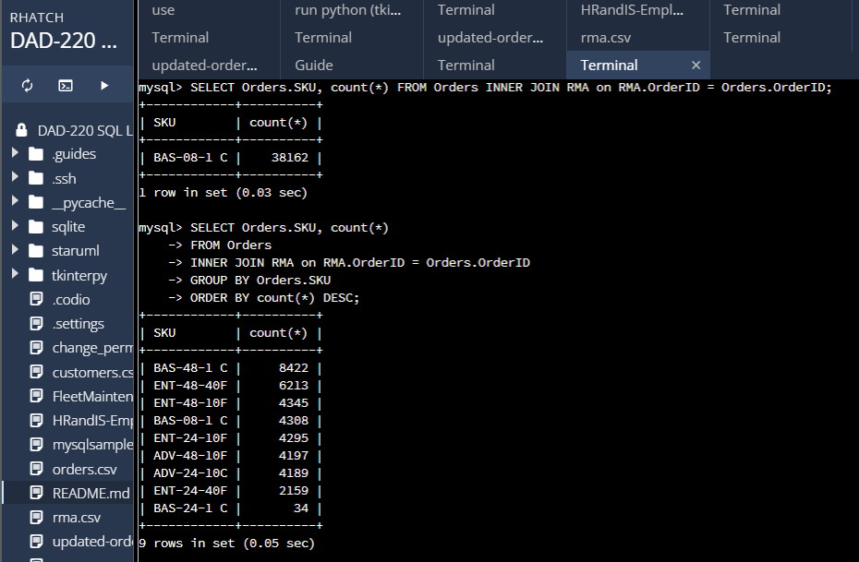

* + 1. **Analyze the data to determine the top three products returned in the northwestern region of the United States.**
       - **Northwestern states to include in your analysis: Washington, Oregon, Idaho, and Montana**> SELECT Orders.SKU, count(*)  
         > from Customers  
         > INNER JOIN Orders on Customers.CustomerID = Orders.CustomerID  
         > INNER JOIN RMA on Orders.OrderID = RMA.OrderID  
         > WHERE Customers.State IN ('Washington','Oregon','Idaho','Montana')  
         > GROUP BY Orders.SKU  
         > ORDER BY count(*) DESC;BAS-48-1C, ENT-48-40F, BAS-08-1 C

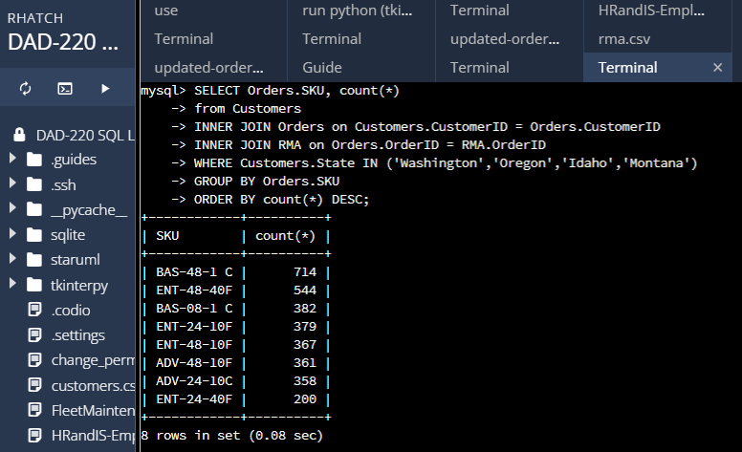

1. **Write a report to the Quantigration product manager that explains your findings in a way nontechnical stakeholders can digest and use.**
   1. **This report should include an effective summary of the analysis of the captured data.**

**Summary of Sales by Region:**

**In our analysis of sales data by region, we have uncovered important insights that can help us understand our customer base and identify key trends. Here are the key findings:**

1. Sales by State: When examining the customer base across different states, we discovered that Massachusetts stands out with the largest number of customers. With a total of 982 customers, it surpasses Arkansas by 128 customers. In terms of percentage, Massachusetts represents 2.58% of our overall business, which is 15% higher than Arkansas.
2. Top Products Sold in the United States: To gain a better understanding of our sales performance nationwide, we looked at the top-selling products in the United States. The three products that have been selling exceptionally well are BAS-48-1 C, ENT-48-40F, and ENT-48-10F. These products have consistently shown high demand and generated significant sales volume.
3. Top Products Sold in the Southeastern Region: We narrowed our focus to the southeastern region, specifically Virginia, North Carolina, South Carolina, and Georgia. In this region, the top three products that have been driving sales are BAS-48-1 C, ENT-48-40F, and BAS-08-1 C. These products have resonated well with customers in the southeastern states**.  
     
   Summary of Returns by Region:**

**Analyzing the returns data by region has provided us with valuable insights into product performance and customer satisfaction. Here's what we found:**

1. Top Products Returned in the United States: When examining returns on a national level, we found that the most frequently returned products in the United States are BAS-48-1 C, ENT-48-40F, and ENT-48-10F. Understanding the reasons behind these returns can help us improve product quality and address customer concerns.
2. Top Products Returned in the Northwestern Region: Shifting our focus to the northwestern states, including Washington, Oregon, Idaho, and Montana, we discovered that the top three products returned in this region are BAS-48-1 C, ENT-48-40F, and BAS-08-1 C. Analyzing return patterns in specific regions can provide valuable insights into regional preferences and potential areas for improvement.

These findings offer a comprehensive overview of our sales and returns data by region, shedding light on customer behavior, product popularity, and areas that require attention. Armed with this knowledge, we can make informed decisions to optimize our sales strategies, enhance customer satisfaction, and drive business growth.